**Koolhaas, Rem (b. 1944)**

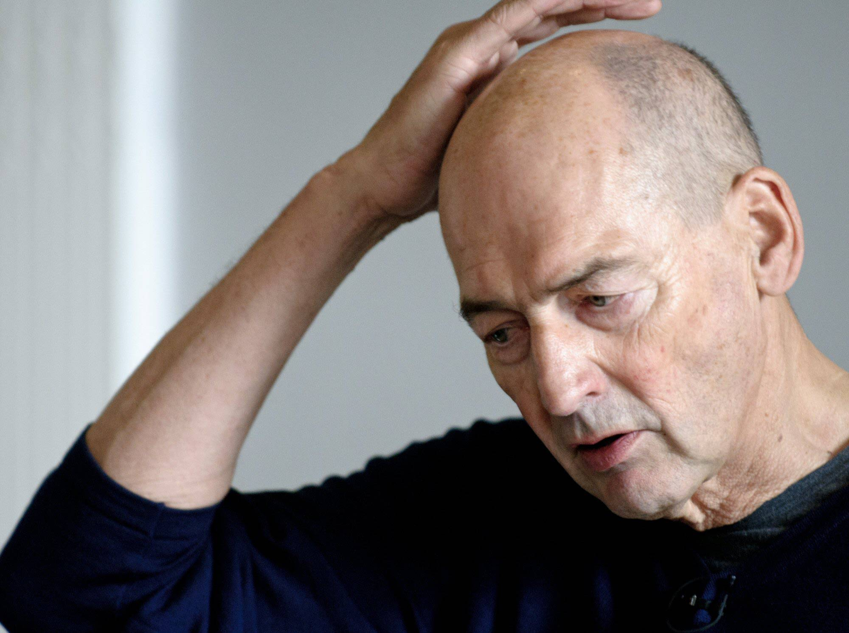

Rem Koolhaas by Ben Pruchnie ©2012 Getty Images for Garage Center in Moscow

<http://0.tqn.com/d/architecture/1/0/U/7/1/rem-koolhaas-2012.jpg>

The Dutch architect Rem Koolhaas (born in Rotterdam) has always had a keen eye for the still vibrant legacy of modernism, calling attention to the ‘terrifying beauty of the twentieth century’. Before beginning his studies in architecture, Koolhaas went to film school and worked as a journalist. In 1968, aged nearly 24, he went to study at the Architectural Association in London and soon found himself exploring the demanding but powerful language of modernity, often in opposition to the dominant culture of the ‘rice-cooking hippies’ at the AA. Since his final project ‘Exodus, or the voluntary prisoners of architecture’ (1972), his work has continued to explore both the underbelly of modernity and its heroic icons, accepting modernity as part and parcel of contemporary culture. Koolhaas’ interest in the demanding architecture of modernism focuses not only on its formal language and style, but also on the underlying social collective it proposed. His work offered a new perspective, celebrating the energy and rigour of modernism while also revealing its underlying characteristics. His recuperation of modernity ranged from the sensuousness of MIES VAN DER ROHE (with materials such as velvet, brass and marble) to the brute force of RUSSIAN CONSTRUCTIVISM (social machinery). Moreover, he included the perhaps less foreseen consequences in his studies: the endless infrastructures, neutral facades, generic spaces.

In 1975, Koolhaas founded the Office for Metropolitan Architecture (OMA), together with artist (and then wife) Madelon Vriesendorp and Elia and Zoe Zenghelis. The office name paid homage to the metropolis as the site of modernity. The firm gained its reputation first with competition entries, exhibitions and publications, and later with a built oeuvre that may be one of the most widely familiar oeuvres in architecture.

His first book, *Delirious New York*, was published in 1978. He presented it as a ‘retroactive manifesto’ proposing that New York was in essence (and accidentally) the constructed ideal that the ideologies of European modernism had never managed to realize. *Delirious New York* contains many ideas elicited from the existing conditions of New York such as the ‘culture of congestion,’ that continue to inform his work today.

The completion of the Kunsthal in 1992 firmly established the reputation of OMA. In the 1990s, OMA were involved in increasingly large scale commissions such as the Très Grande Bibliothèque competition (1989), Seoul International Airport (1995) and Universal Headquarters in Los Angeles (1996). In this period, the essay ‘Bigness’ (1992) suggested a provocative view of new urban conditions, in which architecture had grown to the scale of the city and revived the Constructivist idea of a social condensor, in which the intensity of many different activities would generate new forms of urban collectivity. In addition, OMA was asked for visions on the new European city, most notably designing the master plan for Lille (1992). A few years later ‘Generic City’ (1994) explored the anonymous spaces of the global world, expanding the focus of OMA from the metropolis to the global urban condition in general. This heralded the later research at the Harvard Graduate School of Design studios, which would include studies of the urban logic of non-Western urban agglomerations such as Lagos.

Koolhaas’ reputation as an architect is based not only on his understanding of architecture, but his acumen in connecting the many facets of modern life and culture to architectural propositions. His most recent explorations include the question of heritage and preservation at the Venice Biennale of 2010, the countryside as the counterpoint to the city, the anonymous architecture of the welfare state (Venice Biennale 2012), and a recent studio on the ‘elements of architecture’ from doors to windows and ceilings.

With his sensibility for the frenetic energy of the modern age, Koolhaas has managed to turn attention from the clean beauty of modernism and the International Style to the sublime quality of the global modernity we face today.

**List of Works**

1992 Kunsthal, Rotterdam, Netherlands.

1995 Dutch House, Netherlands.

1998 Maison Bordeaux, Floirac, France.

2001 Prada Flagship Store, New York, USA.

2004 Seattle Public Library, Seattle, USA.

2005 Casa da Musica, Porto, Portugal.

2012 CCTV Building, Beijing, China.

**References and further reading**

Gargiani, R. (2008) *Rem Koolhaas/OMA: The Construction of Merveilles*. London: Routledge.

Koolhaas, R. (2005) ‘The Terrifying Beauty of the Twentieth Century’ in: *SMLXL* (Rotterdam, 010 publishers, pp.204-209.

Koolhaas, R. (2005) *SMLXL* (Rotterdam, 010 publishers).

Lootsma, B. ‘Koolhaas, Constant and Dutch Culture in the 1960s’ (available online: http://www.architekturtheorie.eu/?id=magazine&archive_id=108).

Schrijver, L. (2008) ‘OMA as Tribute to OMU’, *The Journal of Architecture* vol. 13, no. 3, pp.235-261.

*video*

<http://edition.cnn.com/2009/WORLD/asiapcf/06/23/talkasia.remkoolhaas/index.html> (general interview, starchitecture)

<http://www.youtube.com/watch?v=iJnOtIGbZDk&feature=related> (preservation, Venice Biennale 2010)

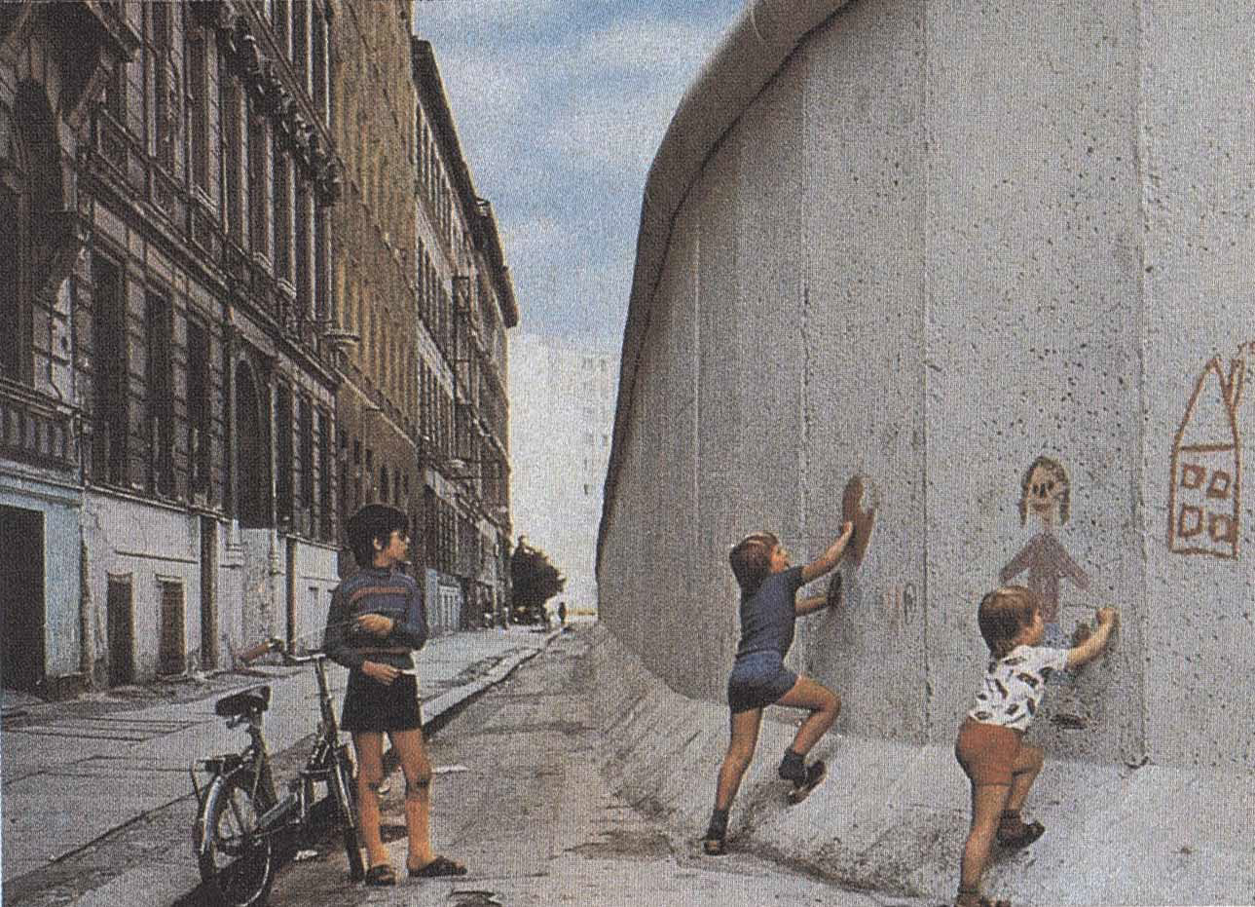

**Berlin Wall, photo for Summer Study project at AA London, 1971**

Children playing along the Berlin Wall. (source / SMLXL, page 229. Photograph by Rem Koolhaas, 1972) *seems like photo should be dated 1971?

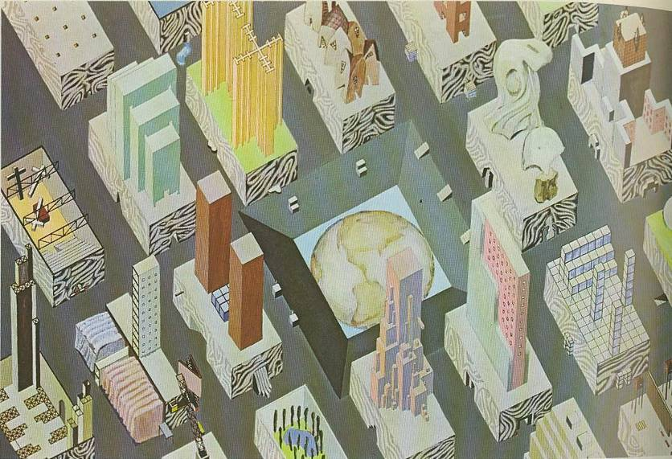

**City of the Captive Globe, 1972**

City of the Captive Globe (1972), including modern icons such as the Plan Voisin by Le Corbusier, the Cabinet of Dr. Caligari, an ‘homage to Mies’, works by El Lissitsky and Leonidov. [Rem Koolhaas and Madelon Vriesendorp, 1972.] with Zoe Zenghelis?

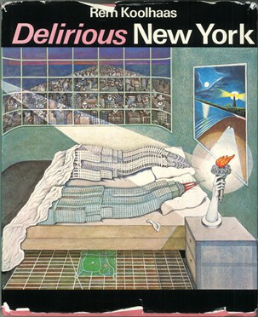

Cover of *Delirious New York*, Thames & Hudson, 1978.

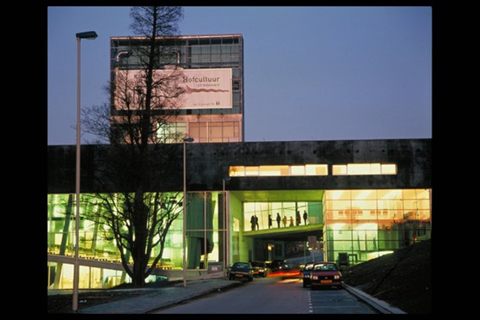

OMA, Kunsthal, Rotterdam, 1992.

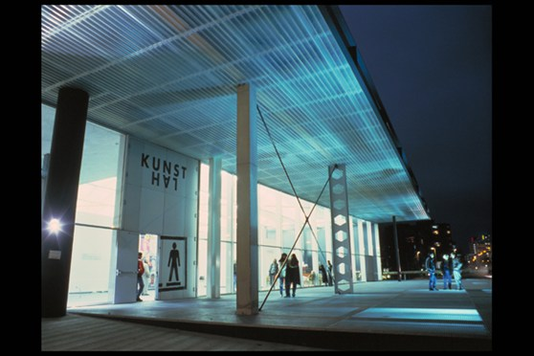

OMA, Kunsthal, Rotterdam, 1992.

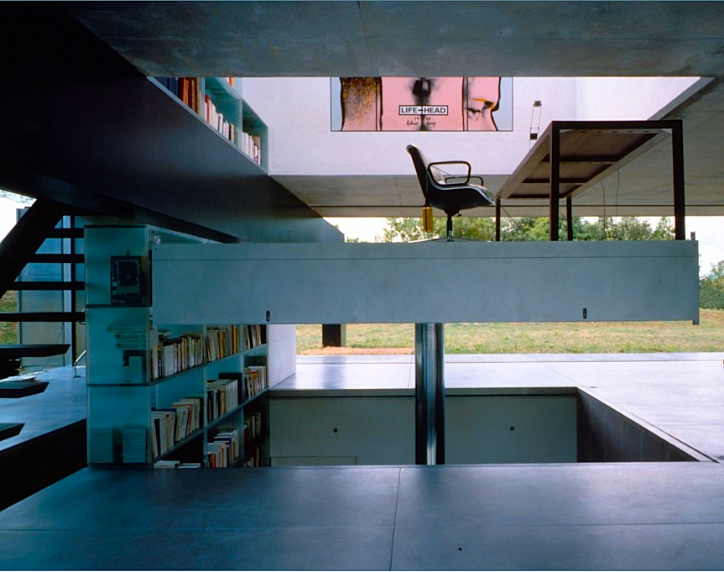

OMA, Maison à Bordeaux, Floirac, 1998.

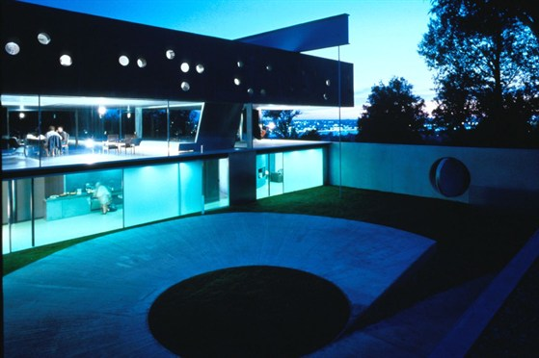

OMA, Maison à Bordeaux, Floirac, 1998.

Lara Schrijver

Delft University of Technology